1. **ForgeRock IG**

Identity Gateway works on reverse web proxy and it’s similar as IBM webseal junction, primarily objective is enforce authentication and authorization. IG integrates web applications, APIs, and microservices with the ForgeRock Identity Platform without changing the application or container where they run.

Open Identity Gateway flow

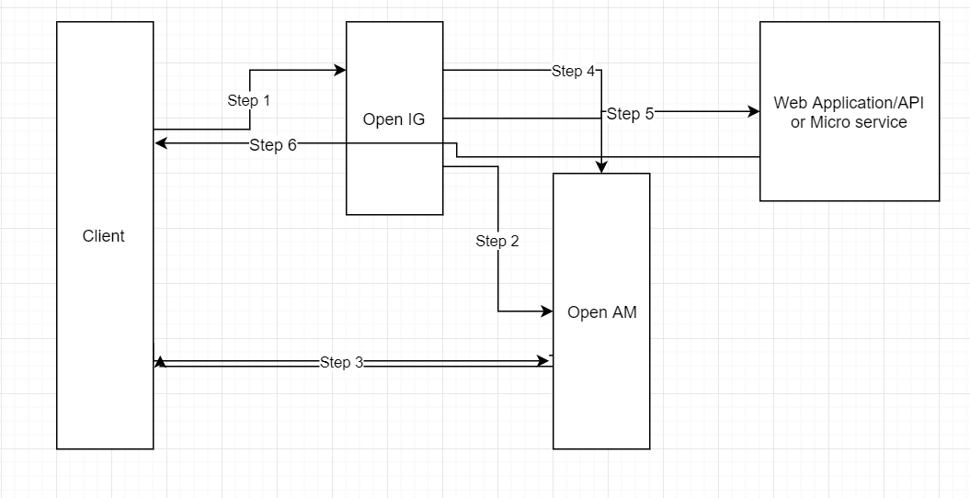

Step 1: Client tries to access Web application/Micro service

Step 2: The IG Container, intercepts the requests and redirects the request to Identity Access Management if ther is no token.

Step 3: The Identity Access Management, first Authenticates the User and redirects to client with token details.

Step 4: The IG sends request to Identity Access Management to authorize User has access to the Webapplication/Micro service

Step 5: Based on the policies defined in the Identity Access Management for the Resource, it will send response to allow or deny the request and sends it back to the IG.

Step 6: based on IAM response IG allow or deny the access of the resource.

**Open IG/IG Version:**

IG version 6.5.0 or Open IG 4.5

[**Web Application Containers**](https://backstage.forgerock.com/docs/ig/6.5/release-notes/index.html#which-container)

We will deploy IG war file on Apache Tomcat 8.5.x or 9 web application containers alon with Java Agent.

**Java Version:**

| [Vendor](https://backstage.forgerock.com/docs/ig/6.5/release-notes/index.html" \l "which-container) | [Versions](https://backstage.forgerock.com/docs/ig/6.5/release-notes/index.html" \l "which-container) |
| --- | --- |
| [OpenJDK](https://backstage.forgerock.com/docs/ig/6.5/release-notes/index.html" \l "which-container) | [8, 11](https://backstage.forgerock.com/docs/ig/6.5/release-notes/index.html" \l "which-container) |
| [Oracle JDK](https://backstage.forgerock.com/docs/ig/6.5/release-notes/index.html" \l "which-container) | [8](https://backstage.forgerock.com/docs/ig/6.5/release-notes/index.html" \l "which-container) |

**[Dev](https://backstage.forgerock.com/docs/ig/6.5/release-notes/index.html" \l "which-container) Ops:**

Docker Container

1. **AM**

AM provides a service called access management, which authentication and authorization access to resources, such as a web page, an application, or web service. It’s similar to IBM SAM.It supports centralized authentication and we will not authenticate against application. Open AM supports seamless federation services.

**Open AM Version:**

AM version 6.5.0

Open AM version 13.5

[**Web Application Containers**](https://backstage.forgerock.com/docs/ig/6.5/release-notes/index.html#which-container)

We will deploy AM war file on Apache Tomcat 8.5.x or 9 web application containers alon with Java Agent.

AM web agent will be deployed on Apache HTTP server.

**Java Version:**

| [Vendor](https://backstage.forgerock.com/docs/ig/6.5/release-notes/index.html" \l "which-container) | [Versions](https://backstage.forgerock.com/docs/ig/6.5/release-notes/index.html" \l "which-container) |
| --- | --- |
| [OpenJDK](https://backstage.forgerock.com/docs/ig/6.5/release-notes/index.html" \l "which-container) | [8, 11](https://backstage.forgerock.com/docs/ig/6.5/release-notes/index.html" \l "which-container) |
| [Oracle JDK](https://backstage.forgerock.com/docs/ig/6.5/release-notes/index.html" \l "which-container) | [8](https://backstage.forgerock.com/docs/ig/6.5/release-notes/index.html" \l "which-container) |

**[Dev](https://backstage.forgerock.com/docs/ig/6.5/release-notes/index.html" \l "which-container) Ops:**

Docker Container

1. **IDM**

Identity management (IdM) describes the management of individual [identities](https://en.wikipedia.org/wiki/Digital_identity), their [authentication, authorization](https://en.wikipedia.org/wiki/Access_control), roles and privileges[[1]](https://en.wikipedia.org/wiki/Identity_management_system#cite_note-1) within or across multiple systems.It’s similar to the IBM SIM.

**Open IDM Version:**

IDM version 6.5.0

Open IDM version 4.5

**Java Version:**

| [Vendor](https://backstage.forgerock.com/docs/ig/6.5/release-notes/index.html" \l "which-container) | [Versions](https://backstage.forgerock.com/docs/ig/6.5/release-notes/index.html" \l "which-container) |
| --- | --- |
| [OpenJDK](https://backstage.forgerock.com/docs/ig/6.5/release-notes/index.html" \l "which-container) | [8, 11](https://backstage.forgerock.com/docs/ig/6.5/release-notes/index.html" \l "which-container) |
| [Oracle JDK](https://backstage.forgerock.com/docs/ig/6.5/release-notes/index.html" \l "which-container) | [8](https://backstage.forgerock.com/docs/ig/6.5/release-notes/index.html" \l "which-container) |

**[Dev](https://backstage.forgerock.com/docs/ig/6.5/release-notes/index.html" \l "which-container) Ops:**

Docker Container